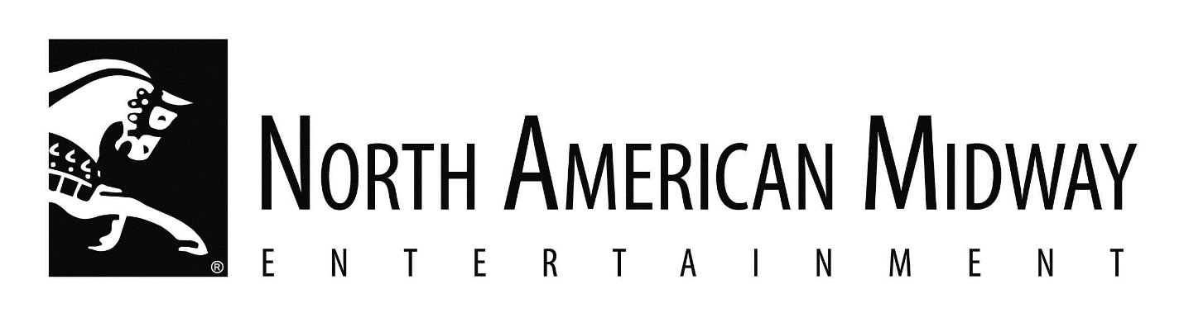

NOW HIRING CARNIVAL FOOD CONCESSION OPERATORS FOR THE 2025 SEASON

North American Midway Entertainment-Canada Co.
17 Corporate Place, Unit C, Brantford, ON N3R 8A6

Job Title: Carnival Food Concession Operators – 30 positions

Job Description:

- Setting up/tearing down & operating food concession booth
- Stocking inventory
- Serving customers
- Routine prep & serving of food
- Must be willing to travel across Canada
- Season begins May 27 in Brandon then travel to Winnipeg, Calgary, Edmonton, Saskatoon, Brandon, Toronto & end in London on Sept. 23
- We provide living accommodations & transportation between locations
- This is a full-time position for approx. 17 weeks
- Wage is $17.60/hr.
- Must be at least 18 yrs of age
- Experience in the carnival tour is preferred but not essential

How to Apply:

Email resume with references to employment@namidway.com or
fax to 519-756-4590 ATTN: Michele Whorpole

