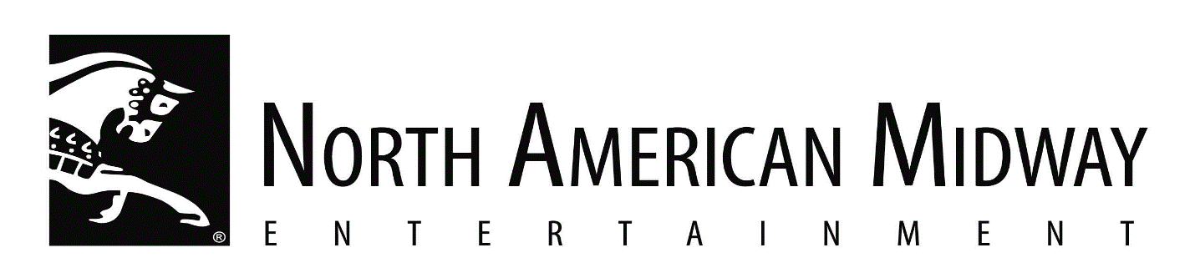

NOW HIRING CARNIVAL RIDE SUPERVISORS FOR THE 2025 SEASON

North American Midway Entertainment-Canada Co.
17 Corporate Place, Unit C, Brantford, ON N3R 8A6

Job Title: Carnival Ride Supervisors – 10 positions

Job Description:

- Coordinating, assigning, supervising & reviewing activities of ride operators
- Training workers in job duties, safety procedures & company policies
- Supervising operation of rides
- Arranging for maintenance & repair work
- Must be willing to travel across Canada
- Season begins May 27 in Brandon then travel to Winnipeg, Calgary, Edmonton, Saskatoon, Brandon, Toronto & end in London on Sept. 23
- We provide living accommodations & transportation between locations
- This is a full-time position for approx. 17 weeks
- Wage is $24.00/hr.
- Must be at least 18 yrs of age
- Experience in the carnival tour is required
- Completion of high school is required

How to Apply:

Email resume with references to employment@namidway.com or
fax to 519-756-4590 ATTN: Michele Whorpole

